One kind of timing-trick

1. Basic rules

Here I remind you the 2 basic rules.

(1) There must be at most 1 laser on the map.

(2)The laser moves in the same speed as a moving tank on tank-movers.

There are some hidden rules when you are moving on tank-movers. However, things are so quick and complex that I don’t intend to tell you the exact process.

There are other kinds of timing-tricks involving (thin) ices, or involving mixed path by (thin) ices and tank-movers. They are even more complex, and if you want to know those rules, you can open “tutor.lvl” file in the game window to learn them.

Next I will show you some situations and will tell you the results of your moves. You can count the number of grids and think why things happened like that.

Probably, your answers are enough to earn the qualification to solve almost all this kind of levels with tank-movers (without ice/thin ices).

2. Examples

See Picture 1.

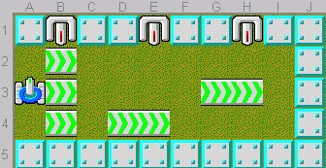

Walk onto B3 tank-mover. You will just be alive. (Walk onto B4 tank-mover and you will be alive too, but B2 will die)

Then walk onto D4 tank-mover. You will just be alive.

Then walk onto G3 tank-mover. You will just get shot.

See Picture 2.

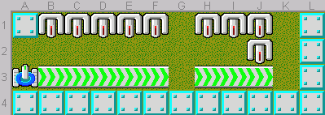

Walk onto B3 tank-mover. You will be alive. In fact, there are 3 ATs who will shoot lasers: B2, D2, and F2.

Then walk onto H3 tank-mover. You will be killed by J2.

See Picture 3.

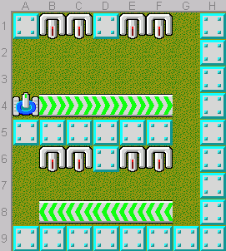

Walk onto B4 tank-mover. You will alive and B4 & E4 ATs will shoot lasers.

Then walk onto F8 tank-mover. You will be killed by C6 AT.

See Picture 4.

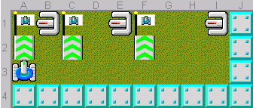

Walk onto A2 tank-mover. You will get shot.

Walk onto C2 tank-mover. You will just get shot.

Walk onto F2 tank-mover. You will just win.

See Picture 5.1.

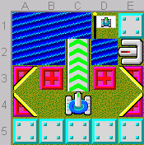

Walk onto C3 tank-mover. You will be killed by E2 AT before sink.

Shoot B3 block to C2, walk onto C3 tank-mover, and shoot left. See Picture 5.2.

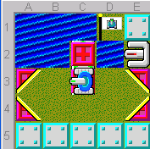

Shoot up, go up. You will be alive.

See Picture 6.1.

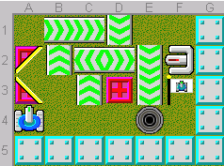

Walk onto C3 tank-mover and wait. You will be alive. See Picture 6.2.

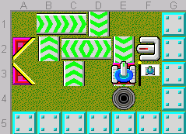

Just on time.

The last scene is weird! See Picture 7.

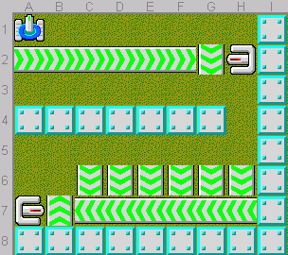

Walk onto A2 tank-mover. As you expect, our tank will be killed.

Walk onto B2 tank-mover. The laser will run through our tank and our tank will keep alive!

Walk onto C1 tank-mover. Killed.

Walk onto D1 tank-mover. Alive.

E1 -> Killed.

F1 -> Alive.

It seems that as long as our tank and the laser don’t appear in the SAME grid, our tank will be alive.

Then go to the bottom room.

H6 -> Alive.

G6 -> Killed.

F6 -> Alive.

E6 -> Killed.

D6 -> Alive.

C6 -> Killed.

It seems that just at the moment when our tank leaves from H6, A7 sees it and shoots a laser. On the other hand, it seems that H2 AT cannot see us before our tank suddenly appear on A2.

If you want to test these examples or some supposes of yourself, you can click “Editor” in the game window to do it.

3. Lasertank Collection (You can manipulate them in your computer)

(1) #0114 “Death Trap?” by Chris Kaeser, Difficulty: Easy. (Picture 8.1)

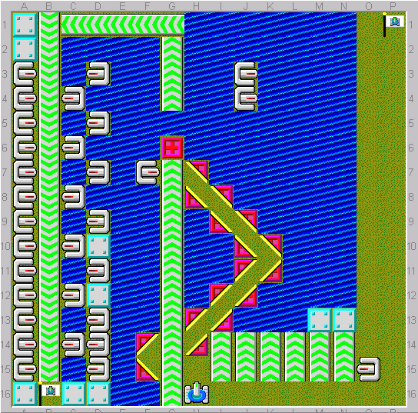

Push O15 AT to O2, kill F7, and arrive on G5. See Picture 8.2.

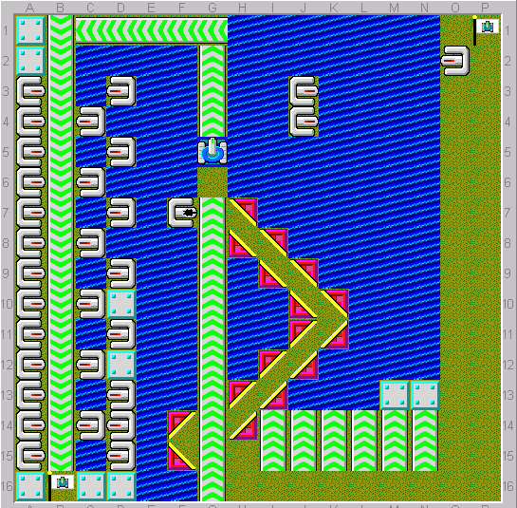

Go up and the interesting things will happen!

(2) #0099 “Tricks and Traps” by Manzi, Difficulty: Medium. (Picture 9)

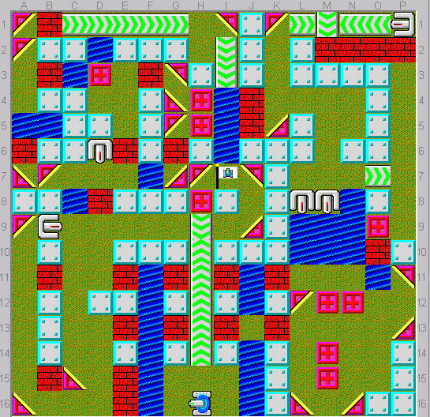

Follow the hint and see what will happen.

(3) #0404 “Triple Shot” by James Smith, Difficulty: Hard. (Picture 10.1)

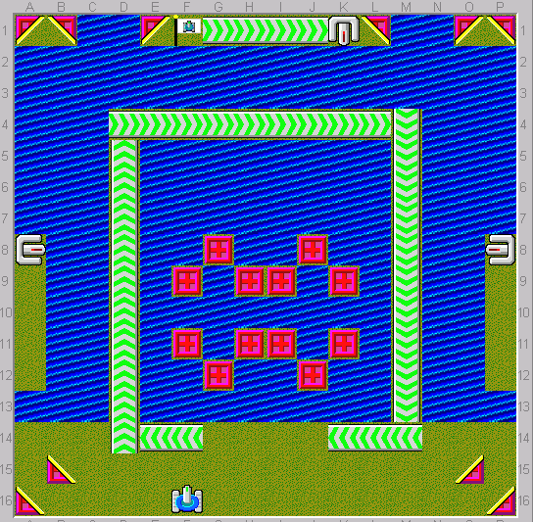

This is a classical level involving timing-tricks. You should be very careful of things below:

Save enough blocks.

Push tanks to right places in order to let the right tank shoot at the right time.

Don’t be killed.

See Picture 10.2 as a possible ending.

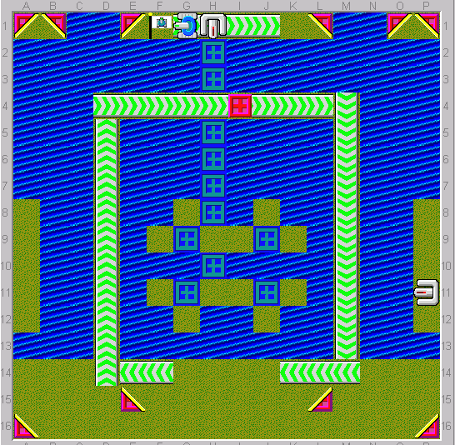

4. Further recommendations (Don’t try them until you get trained)

(1) Challenge-III_1853 “The sun and moon are long” by Li Yifeng, Difficulty: Hard. (Picture 11)

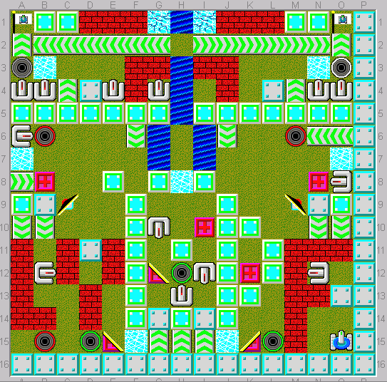

(2) #0666 “Blind Beast” by Kheper, Difficulty: Deadly. (Picture 12)

